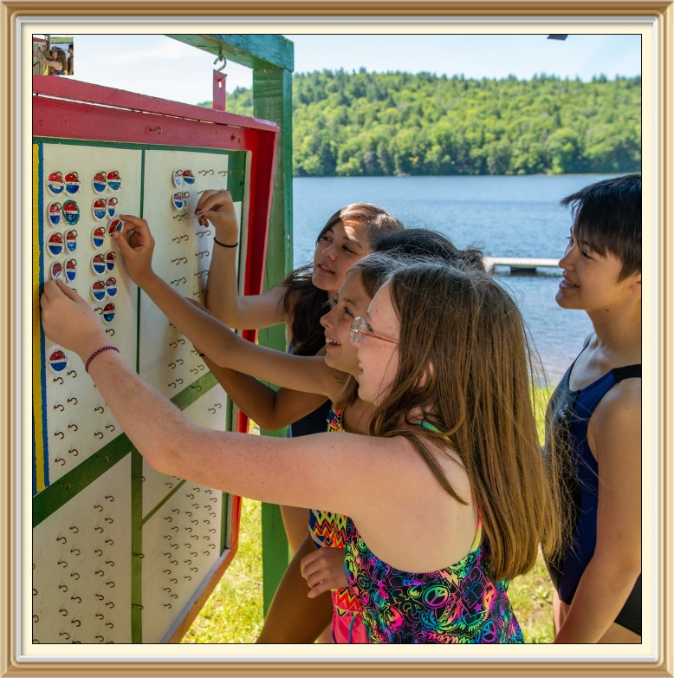
FACILITATORS GUIDE
Safe Swim Defense

  - Course Description
  - All BSA swimming activities must be supervised by an adult age 21 or older who is trained in and committed to compliance with the eight points of BSA Safe Swim Defense. This course is one of only two approved options for adults to receive that training. Training consistency requires that both online and in-person formats provide the same essential content in the mandatory video segments.
  - The most common delivery option for this training is the online, mobile friendly, version via my.Scouting.org which is available 24/7 to accommodate individual schedules. That version also automatically updates the participant’s training record.
  - However, the online version requires an internet connection which may not be available at some training sites, such as council summer camps. This course option may be downloaded to avoid that restriction.
  - The in-person version of the course also provides participants the opportunity to interact in a group environment and ask questions. Some participants may prefer and better respond to the chance to interact.
  - In this classroom setting, it is crucial that the facilitator only allows valid information to be acknowledged. The facilitator should be familiar with and have access during the session to both the current text of Safe Swim Defense in the Guide to Safe Scouting and the BSA Aquatics Supervision guide that provide additional detail. In addition, the PowerPoint file can be used to repeat select content in the videos for clarification. If unambiguous answers to questions cannot be found in those resources, the facilitator should not allow individuals to present opinions as facts. Ideally, the facilitator will have training as a BSA Aquatics Instructor, a BSA Lifeguard Instructor, or a BSA Swimming and Water Rescue Instructor.
  - In addition, the facilitator should also review the Guide to Leader Training and consult with the council service center for attendance and record keeping procedures.

  - Class Objectives
  - After completing this training, participants will be able to:
- Identify important current safety data related to Safe Swim Defense
- Recognize the requirements associated with the eight Key Safety Points of Safe Swim Defense during Scouting swimming activities
Target Audience
This course is targeted for mature and conscientious adults age 21 or older who will be supervising Safe Swim Defense BSA swimming activities.
Class Timeline: 60 minutes
Time | Topic | Delivery Method(s)
3 minutes | Introduction | Facilitator/Video
8 minutes | Risk Factors | Video
2 minutes | Qualified Supervision | Video
2 minutes | Personal Health Review | Video
6 minutes | Safe Area | Video
3 minutes | Response Personnel | Video
2 minutes | Lookout | Video
6 minutes | Ability Groups | Video
2 minutes | Buddy System | Video
2 minutes | Discipline | Video
20 minutes | Course Quiz | Quiz/Answer Review
4 minutes | Conclusion | Video/Commitment
As time allows | Q&A | Facilitated discussion

Preparation Checklist
Open the PowerPoint, and practice launching videos
Review expected attendance
Print Course Quizzes, Training Attendance Report and Fillable Training Cards
Review this Class Facilitator Guide, Safe Swim Defense in the Guide to Safe Scouting, and Aquatics Supervision.
Set-up meeting location, check computer connections, visibility of projection screen, video volume, etc.
Material for Distribution
Course Quiz
Training Attendance Report (link)
Certificates of Training cards (link)

Time: 3 minutes | Introduction
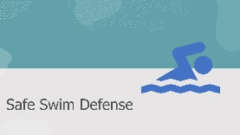  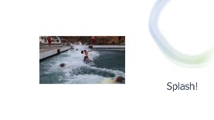  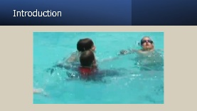 | - Open and project the PowerPoint on the screen.  - Welcome each participant as they come into the classroom.  Feel free to paraphrase the comments written after each “SAY:” prompt to reflect your own conversational style.  SAY: My name is ______ and I will be serving as your facilitator today. We will be looking at several Safe Swim Defense videos and have a course quiz with related questions at the end. Let’s jump in!  Click to advance slide and play the Splash video.  SAY: We encourage you to follow these points of basic Classroom etiquette:  - Turn off email and phones and clear other distractions from your training area.  - Time is scheduled for questions and discussions, so please do not talk among yourselves as the videos are playing.  Following today’s training session you will be presented with a completed training certificate pocket card (No. 33767 link).  Click to advance slide and play the Introduction video.  SAY: Now that you have seen that the Safe Swim Defense guidelines apply to all Scouting swimming activities, let’s take a look at risk factors.

Time: 8 minutes | Risk Factors
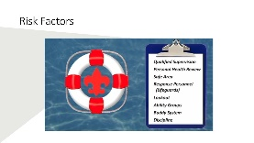 | Click to advance slide and play the video on the Risk Factors slide.  SAY: So let’s begin with the first point of Safe Swim Defense.

Time: 2 minutes | Qualified Supervision
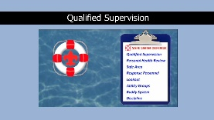 | Click to advance slide and play the video on the Qualified Supervision slide.  SAY: So we reviewed the importance of training and commitment to the safety of the Scouts in our care.

Time: 2 minutes | Personal Health Review
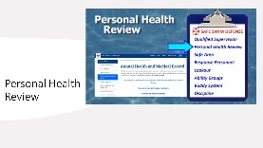 | Click to advance slide and play the video on the Personal Health Review slide.  SAY: Reviewing each participant’s personal health history is an important way to anticipate potential risks from individual health conditions. Let’s look at the next point.

Time: 6 minutes | Safe Area
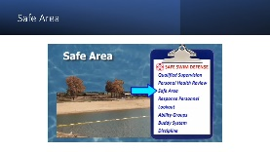 | Click to advance slide and play the video on the Safe Area slide.  SAY: Now that we have reviewed several topics under Safe Swim area, let’s look at the role of response personnel.

Time: 3 minutes | Response Personnel
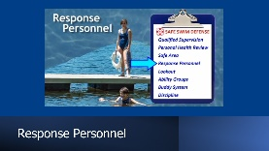 | Click to advance slide and play the video on the Safe Area slide.  SAY: A trained rescue team is aided by the Lookout featured in this next video.

Time: 2 minutes | Lookout
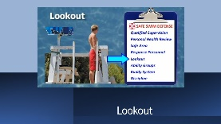 | Click to advance slide and play the video on the Lookout slide.  SAY: What role do Ability Groups have? Let’s watch and find out.

Time: 6 minutes | Ability Groups
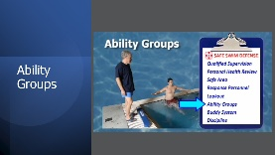 | Click to advance slide and play the video on the Ability Groups slide.  SAY: Next, let’s see how the Buddy System provides an extra pair of eyes.

Time: 2 minutes | Buddy System
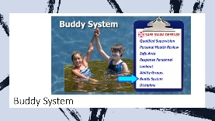 | Click to advance slide and play the video on the Buddy System slide.  SAY: Since Scouts will be having fun, we need to pay attention to safety procedures.

Time: 2 minutes | Discipline
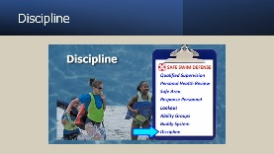 | Click to advance slide and play the video on the Discipline slide.  SAY: Okay, now it is time for review of what we have been learning.

Time: 20 minutes | Safe Swim Defense Course Quiz
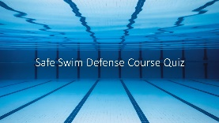 | Click to advance slide.  SAY: I will hand out the course quiz I mentioned earlier. Mark your answers on the sheet by circling the letter of your answer choice. When everyone is finished, I will identify the correct answers. You will have about 15 minutes to complete the quiz.  - Be prepared to answer simple questions anyone may have relative to material they do not understand which might be covered on the quiz.  - Ask anyone who has a question during the quiz to raise their hand.  - Hand out the course quiz to each student.  - Track the time and let students know when there is about 5 minutes left.  - Call time and use the following notes to identify the correct answers and explain why they are correct.  - Tell students what the correct answers are and provide the explanations for why those answers are correct using the answer key below:
- Is the following statement True or False? Safe Swim Defense policy is the same for Cub Scouts as it is for Scouts BSA.

- True (Correct)
- False
SAY: The correct answer for question 1 is “True.” Detailed application of Safe Swim Defense will vary depending on the location and the skill level of the participants, but the rules are the same for all age groups.

- In the U.S., automobile accidents are the leading cause of accidental deaths. What is the second leading cause of accidental death for youth of Cub Scout and Scout BSA ages?

- Fires
- Falls
- Drowning (Correct)
- Poison
SAY: The answer for question 2 is drowning, which is the second leading cause of accidental death for Scout-age youth.

- Which of the following are NOT characteristics of a drowning non-swimmer?

- Ineffective struggling with head back
- Calling for help and reaching for a floatation aid (Correct)
- Becoming passive, followed by submersion
SAY: On question 3, a tired, frightened, or injured swimmer may call out for help and move toward safety. A drowning non-swimmer can do neither. Answer B is correct.

- Which of the following is a major safety concern at an ocean beach, responsible for more rescues than any other?

- Undertow
- Drift current
- Rip current (Correct)
- Surf
SAY: C. “Rip current” is the correct answer for question 4. Rip currents are major hazards at beaches on the ocean or very large bodies of fresh water such as the Great Lakes.

- The supervisor for a swim must be:

- 21 or older
- Trained in Safe Swim Defense
- Trained in Aquatics Supervision: Swimming and Water Rescue
- A and B (Correct)
- A, B and C
SAY: The correct answer for question 5 is D since both A and B are true. The supervisor must be 21 or older and trained in Safe Swim Defense. Additional training is recommended but not required.

- A person may lose consciousness and submerge due to which of the following circumstances?

- Drowning
- A heart attack
- A seizure
- All of the above (Correct)
SAY: The correct answer for question 6 is D. A person may need rescue due to any of the listed items.

- Given these water bottom contours, which area on this chart is for non-swimmers?

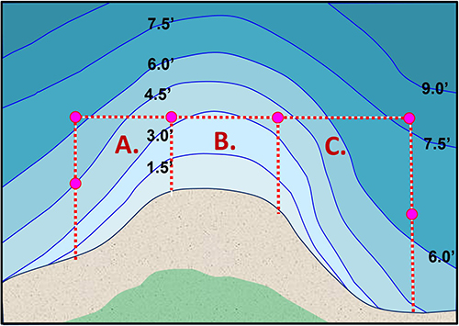

- Area A
- Area B (Correct)
- Area C
SAY: B is the correct answer for question 7. Non-swimmers are limited to standing depths, ideally waist- to chest-deep water.

- Underwater swimming is prohibited in which of the following circumstances?

- When the water is less than 3 feet deep
- At night
- In murky or turbid water (Correct)
- When water temperature is less than 70° F
- All of the above
SAY: C is the correct answer for question 8. Underwater swimming is prohibited when response personnel cannot see swimmers below the surface.

- Headfirst diving is allowed only into clear, deep water. What is the maximum height above the water allowed for headfirst diving?

- 18 inches
- 40 inches (Correct)
- 5 feet
- 10 feet
SAY: The correct answer for question 9 is B. Diving is not allowed from heights more than 40 inches above the water, which is the typical height of the low board at public pools.

- Feet first entry from a height, such as from a rope swing, requires consideration of:

- Water depths, both minimum and maximum
- Obstructions, such as submerged rocks
- Ability to limit entry to feetfirst
- All of the above, plus others (Correct)
SAY: For question 10 the correct answer is D. All of these are appropriate safety concerns.

- Generally, feetfirst entry into deep, unobstructed water should be limited to heights no greater than which of these options?

- Knee high
- Waist high
- Chest high
- Head high (Correct)
SAY: The correct answer for question 11 is D. Additional consideration of risks is needed for feetfirst entries from higher than a person’s height.

- Is this statement True or False? At a swimming area with professionally trained lifeguards on duty, the Qualified Supervisor must assign a sufficient number of unit members as response personnel to maintain a 1:10 ratio of rescuers to participants.

- True
- False (Correct)
SAY: For question 12 this statement is false. Since the appropriate number of lifeguards is mandated by state and local regulations unit members should notify the venue lifeguards of a swimmer needing rescue rather than undertake rescues themselves.

- Is this statement True or False? The person serving as the Qualified Supervisor may also serve as the Lookout at the same time.

- True (Correct)
- False
SAY: The statement in question 13 is true. The Qualified Supervisor and the Lookout may be the same person or two individuals.

- The swimmer classification for general activities in deep water includes a total distance of which of these options?

- 50 feet
- 50 yards
- 75 yards
- 100 yards (Correct)
- Twice the width of the swimmer’s area
SAY: The correct answer for question 14 is D. 100 yards is the total distance, with the first 75 yards swum in a strong manner, followed by 25 yards of a restful backstroke.

- For a hotel pool with depths from 3-5 feet, how many areas for ability groups are needed if the unit contains swimmers, beginners, and non-swimmers . . . some of whom are less than 5 feet tall?

- One
- Two (Correct)
- Three
SAY: The answer for question 15 is B. Nonswimmers should be restricted to water between waist and chest deep. Both beginners and swimmers may swim in a pool section with maximum depth of 5 feet.

- A buddy check does which of the following:

- Reminds buddies of their responsibility to watch one another
- Allows the Qualified Supervisor to judge if buddies are watching one another
- Provides a check of the safety of everyone known to be in the water
- Eases the duty of rescue personnel to closely watch everyone
- All of the above
- A through C (Correct)
SAY: F is the correct answer for question 16. Buddy checks serve the first three functions but are not conducted often enough to replace surveillance by rescue personnel.

- When a unit swims at a public pool with trained lifeguards on duty, the qualified supervisor is still responsible for:

- Implementing precautions based on health histories
- Assigning and tracking buddy pairs
- Designating areas appropriate for different ability groups
- Helping to maintain discipline
- All of the above (Correct)
SAY: The correct answer for question 17 is E. The supervisor need not assign rescue personnel but must abide by the other points of Safe Swim Defense.

Time: 4 minutes | Conclusion
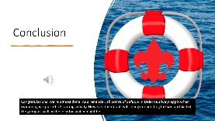  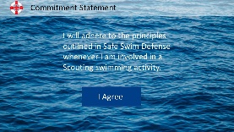  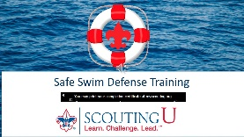 | Click to advance slide and play the video on the Conclusion slide.  Click to advance the slide.  Read the statement on the slide out loud.  SAY: If you agree with the commitment statement on this slide, please raise your hand.  Click to advance to the final slide and play the audio.

Time: As Appropriate | Q & A Session
ASK: Does anyone have any questions or comments?

- For questions, it is appropriate to allow other participants to provide and discuss answers, so long as the facilitator guides everyone to the correct answer in the resource material at hand. If there is no clear answer, offer to get back to the audience later.
- As interest wanes or time advances, take one last question for the group, and offer to stay to discuss further with individuals after the group is dismissed.
Pass around the Training Attendance Report and provide a Certificate of Training to each student.

