Course Quiz
Safe Swim Defense

Question # | Questions and Answer Choices
1  2  3  4  5  6  7  8  9  10  11  12  13  14  15  16  17 | Please answer the following questions by circling the letter of your answer choice.  Is the following statement True or False? Safe Swim Defense policy is the same for Cub Scouts as it is for Scouts BSA.  - True  - False  In the U.S., automobile accidents are the leading cause of accidental deaths. What is the second leading cause of accidental death for youth of Cub Scout and Scout BSA ages?  - Fires  - Falls  - Drowning  - Poison  Which of the following are NOT characteristics of a drowning non-swimmer?  - Ineffective struggling with head back  - Calling for help and reaching for a floatation aid  - Becoming passive, followed by submersion  Which of the following is a major safety concern at an ocean beach, responsible for more rescues than any other?  - Undertow  - Drift current  - Rip current  - Surf  The supervisor for a swim must be:  - 21 or older  - Trained in Safe Swim Defense  - Trained in Aquatics Supervision: Swimming and Water Rescue  - A and B  - A, B and C  A person may lose consciousness and submerge due to which of the following circumstances?  - Drowning  - A heart attack  - A seizure  - All of the above  Given these water bottom contours, which area on this chart is for non-swimmers?  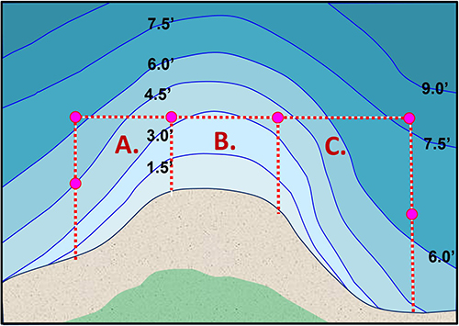  - Area A  - Area B  - Area C  Underwater swimming is prohibited in which of the following circumstances?  - When the water is less than 3 feet deep  - At night  - In murky or turbid water  - When water temperature is less than 70° F  - All of the above  Headfirst diving is allowed only into clear, deep water. What is the maximum height above the water allowed for headfirst diving?  - 18 inches  - 40 inches  - 5 feet  - 10 feet  Feet first entry from a height, such as from a rope swing, requires consideration of:  - Water depths, both minimum and maximum  - Obstructions, such as submerged rocks  - Ability to limit entry to feetfirst  - All of the above, plus others  Generally, feetfirst entry into deep, unobstructed water should be limited to heights no greater than which of these options?  - Knee high  - Waist high  - Chest high  - Head high  Is this statement True or False? At a swimming area with professionally trained lifeguards on duty, the Qualified Supervisor must assign a sufficient number of unit members as response personnel to maintain a 1:10 ratio of rescuers to participants.  - True  - False  Is this statement True or False? The person serving as the Qualified Supervisor may also serve as the Lookout at the same time.  - True  - False  The swimmer classification for general activities in deep water includes a total distance of which of these options?  - 50 feet  - 50 yards  - 75 yards  - 100 yards  - Twice the width of the swimmer’s area  For a hotel pool with depths from 3-5 feet, how many areas for ability groups are needed if the unit contains swimmers, beginners, and non-swimmers . . . some of whom are less than 5 feet tall?  - One  - Two  - Three  A buddy check does which of the following:  - Reminds buddies of their responsibility to watch one another  - Allows the Qualified Supervisor to judge if buddies are watching one another  - Provides a check of the safety of everyone known to be in the water  - Eases the duty of rescue personnel to closely watch everyone  - All of the above  - A through C  When a unit swims at a public pool with trained lifeguards on duty, the qualified supervisor is still responsible for:  - Implementing precautions based on health histories  - Assigning and tracking buddy pairs  - Designating areas appropriate for different ability groups  - Helping to maintain discipline  - All of the above

