NEW! Whitewater Rafting BSA Award

Many Scouting units participate in rafting trips conducted by outfitters or councils. A new aquatics award, Whitewater Rafting BSA, recognizes the challenge and adventure of such activities.
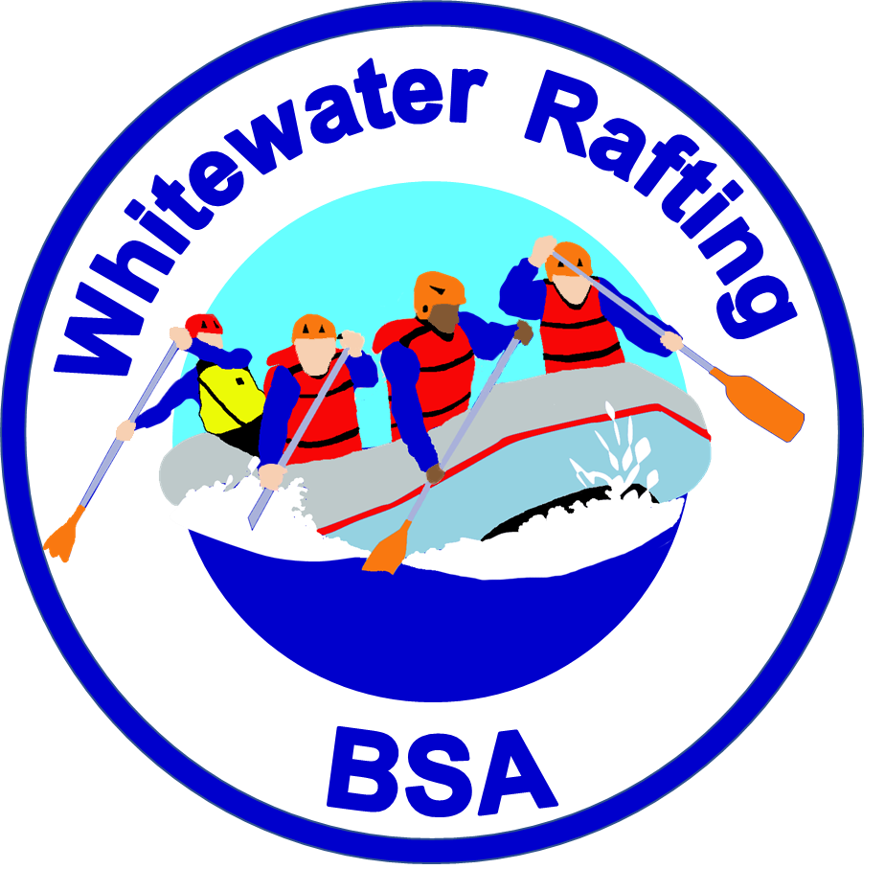
The award is available to BSA youth and adults who are members of Boy Scout, Varsity, Venturing, or Sea Scout units.
Requirements for the award focus on safety and basic paddling skills on whitewater up to Class III. All instruction and skill completions are directly supervised by a professionally trained or licensed rafting guide. A qualified raft captain must be in each raft during the required trip. Participants help power and control the raft with paddles – simply riding in a raft rowed by a guide is not sufficient.
Patches and pocket cards are in production and will be available at scoutstuff.org and in local Scout Shops later this season. A support brochure is also planned.

