Clear Away The Clutter
Make campers feel safe through environment management
By Matthew Surber
BEHAVIOR IS MULTI-FACETED. The “duck on the water” metaphor is extremely apt as sometimes we only see a child who appears quite calm and relaxed, but is likely churning on the inside. When that internal churning changes from the inside to the outside, we are often called to respond — usually without all of the information.
With my staff members and volunteers this past summer, I began using an equation to discuss behavior:
Behavior = Energy + Context + Trigger
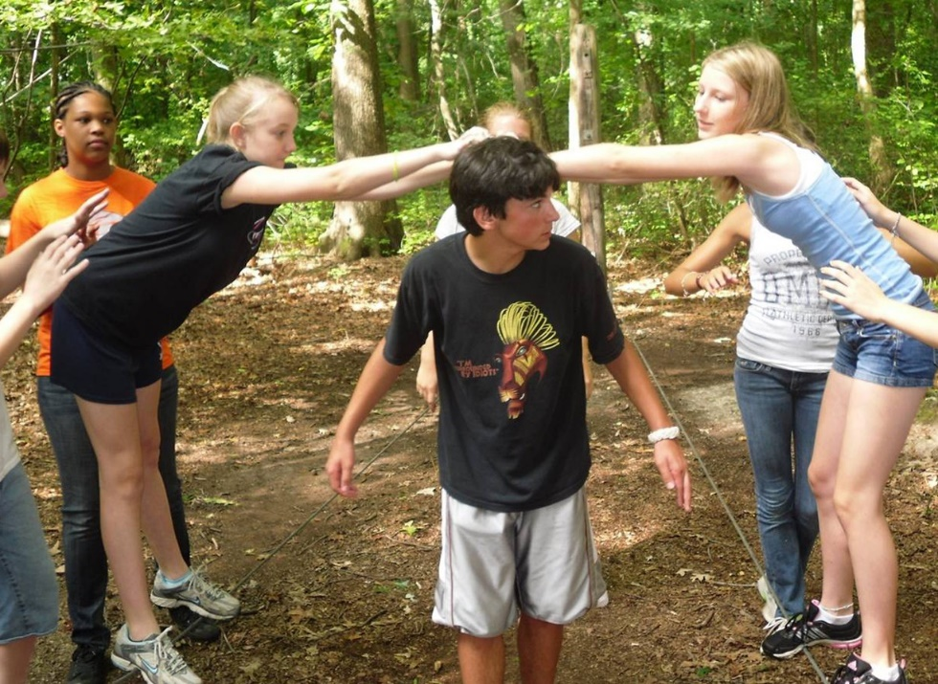
The behavior we see from a kid is tempered by the amount of energy involved at the time. A heated argument usually results in a heated kid. That argument also works as a great trigger to set off a series of events that result in language or fists or any number of inappropriate ways for a child to release the emotional overflow. Finally, we add in context — everything we don’t know about the history of that child. Maybe he or she is yelled at when at home so that type of fear immediately sends the child into a spin.

All of these elements are fairly straightforward when thinking about them, but I should probably add a fourth — environment. What does the world look like around me? How does it match what I know and where I feel most safe?

Environment Triggers Emotions
This is a crucial issue and greatly impacts how behaviors will be manifested. Let’s respect the fact that environment can be both a trigger and a de-fuser of emotional states. When a child walks into a place that is poorly kept, messy, and in a general state of disrepair, it has a powerful effect on whether he or she feels safe and comfortable.
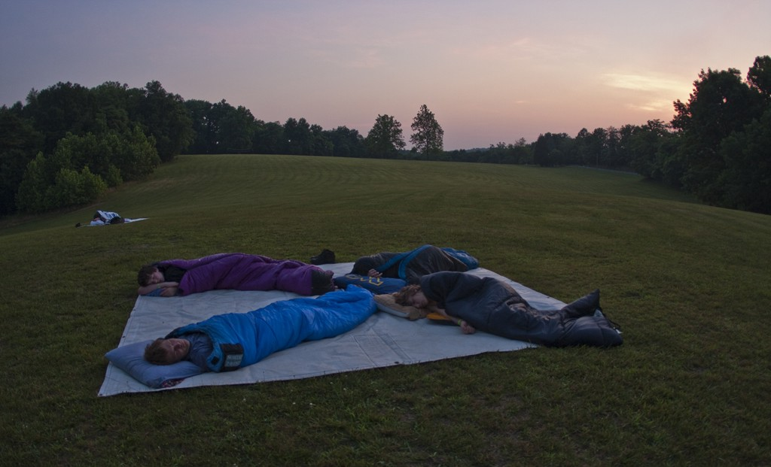
If a kid comes from a warm home with cozy carpeted floors and cushioned sofas and is suddenly dumped in the middle of a wilderness campground with hard-packed dirt and tree stumps for chairs, it could heavily damage a sense of comfort and safety.
Or consider the opposite: If a kid comes from a home where not everyone has a bed or enough food to eat and arrives at camp where everyone has everything they need, it’s like bathing in comfort. A child may immediately feel safe, cared for, and loved.

More Than Maintenance
So what does this mean for us and how we think about what we do? Well, first, maintenance isn’t just about keeping buildings and equipment working. Maintenance is love. If you believe in the Broken-Window Theory (dealing with the little issues helps avoid the big issues), then every repair around a camp is one that signals an astute level of care. A camper will come to believe that if you take such good care of the things at camp, you’ll take good care of the people at camp.
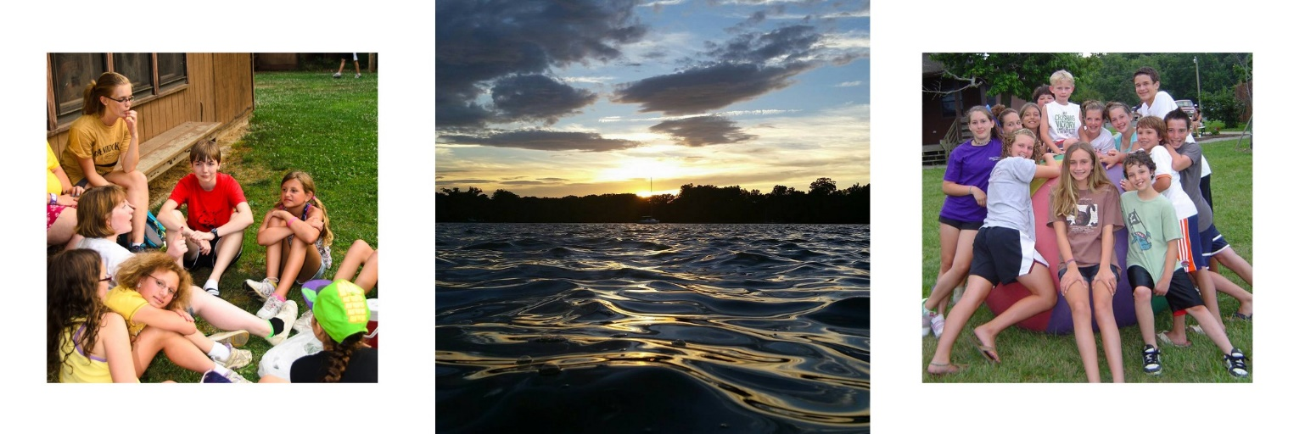
Second, it’s important to admit that our camps are looking less and less like the homes our campers come from. Forty years ago, most kids didn’t have air conditioning at home, there was no great inundation of technology, and being outside for long periods of time was standard. This is not a call to change the way we operate a camp, but a reminder that a camp looks less and less like home for many of these kids. We encourage them to disconnect technologically, we keep them outside for hours on end, and air-conditioned buildings can be scarce.
A sudden lack of these elements can cause an immediate change in the level of discomfort, which might lead to some severe behavior as a child tries to express this new emotional state. A slow, loving transition with a lot of communication about expectations can go a long way to help a young person make the switch. In general, we find a kid is absolutely willing to give up some of those things when he or she knows about it in advance and can mentally prepare.

Set Boundaries
Finally, I like to encourage camp personnel to think about the nature of their environment in regards to what they want kids getting into. My wife and I recently adopted a puppy and went through a whirlwind of changes and tactics to help set the right boundaries and expectations. This, of course, was after our pup ate a few remotes, pulled down some curtains, tore a coat rack out of the wall, and devoured several cherished books.
Once we realized the nature of the problems, we were able to establish hard, clear boundaries, and surround our dog with safe and appropriate play toys. Obviously, children aren’t the same as dogs, but kids certainly deserve the same type of discernment about a new environment.
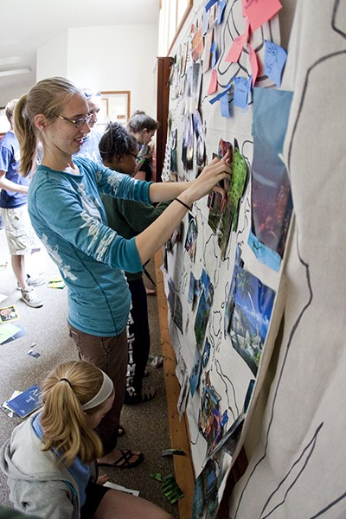
Ask yourself a few questions about the rooms and spaces kids will occupy:
- Are there obvious and clear boundaries? (Will kids know where they should and shouldn’t be without constant reminders?)
- What can kids easily get into? (If campers can easily get into all the things you want them to stay away from, perhaps you should rethink what’s handy.)
- What acceptable things are accessible? (If you want kids to play with the basketballs, do the kids have to get through locked doors and cabinets to get the balls out?)
- Does the setting reinforce the lessons you are focusing on? (If you’re working on quieter tones and calmer activities, being in a busy place is going to work against you.)
- Can campers be comfortable here? (Having a long discussion in air conditioning is easy, but having that same discussion in sweltering heat can be almost impossible.)
A disorganized space, with a lack of seating and many exposed activity materials (markers, balls, scissors, chairs, etc.) makes for a lousy space in which to bring a group. The disorganization can lead to over-stimulation as campers’ eyes shift from one thing to the next. All of the easily accessible materials become toys in the hands of any precocious child, whether it’s nap time or game time.
Take that same room and add cabinets and containers for storage. Move a few sofas and chairs into the space for seating, and make sure everything is comfortable. Suddenly you’ve created a space with clear boundaries (if you ask the kids to sit, they’ll know where) and controlled over-stimulation and activity level.
The environment isn’t the most important element when dealing with kids’ behaviors, but it’s crucial to setting up your group for success. Take the time to consider how one piece is affecting the other and make necessary changes. This can be the difference between a basketball going through a window or through a hoop on the court.
Not taking the time to properly survey and prepare an area is akin to putting kids in canoes without life vests. We create safety by surrounding kids with an environment we control. When the environment is safe, kids can thrive and grow. When kids are unsafe, their behaviors will reflect that fear.
As you look toward next year, think about how you can include environment management into your training curriculum. I promise that once it becomes a utilized skill, you’ll see a drastic difference in the way behaviors are expressed. It will be a world-changer, quite literally. CB
Matthew Surber is the program director for the West River United Methodist Retreat and Camping Ministries in Churchton, Md. Reach him at (410) 867–0991, or westriver.program@verizon.net.

