Instructions for Creating Advanced Power Pivot Table Spreadsheets
from Commissioner Tools Reports

The Power Pivot Table spreadsheets are volunteer developed, and are NOT supported by BSA’s Information Delivery Group. Presently, these spreadsheets only work on a Windows-based computer with EXCEL 2013 and newer. i.e., they do not work with EXCEL 2010 and earlier. Consequently, at this time the utility of these files will be limited to less than all users. Pending the passage of time and the deployment of the appropriate technology to society overall we hope to expand the supported user base. In the meantime, if you do not have a version of EXCEL 2013 or newer, and wish to use these files, you may want to use your local resources to use these Power Pivot spreadsheets. For assistance with these Power Pivot spreadsheets please contact commissioner.support@scouting.org and a volunteer will respond to you.
The Power Pivot spreadsheets may be updated from time to time when new reports become available or technology changes. Be certain to check back to the website occasionally to verify you have the latest version.
When reviewing some of the sample reports found in the Power Pivot spreadsheets you may see a black block obscuring some information. To avoid this you can either:
- Download the spreadsheet or
- Print the sheet you want to use
On the webpage where the Power Pivot spreadsheets are located, there are several files found. One of them is a PDF called Commissioner Tools Power Pivot Tables. This file gives a detailed breakdown of what information can be found in each of the reports in available as Power Pivot files.
For those of you that wish to utilize Sub-districts in your Power Pivot spreadsheets, they are found in each of the 4 Power Pivot spreadsheets. Just scroll through the tabs found at the bottom of the page to find them. They are designated with an sd.
When downloading or saving the CSV file from Commissioner Tools, please be certain to save it as a CSV file. Any other format will not work correctly with the Power Pivot Spreadsheets.
Prior to creating any Power Pivot spreadsheets, you will want to download and save to your computer each spreadsheet that you want to utilize. Don’t open in EXCEL online, but download them. The first time you download and open them you may be asked to Enable Editing or Enable Content. If either of these questions arise, click the button to enable them.

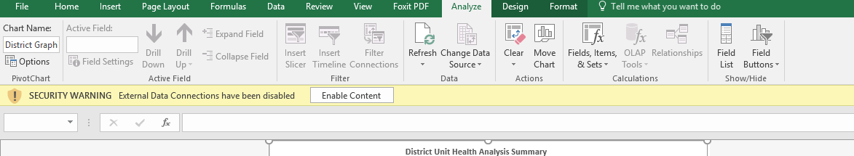

There are 4 steps for creating a Power Pivot spreadsheet:
Step 1) Run Commissioner Tools report
Step 2) Download CSV file
Step 3) Open tool (XLSX), and load the CSV file
Step 4) Analysis reports ready to print or PDF

A detailed step by step demonstration of how to create a sample report follows:
Step 1) From Commissioner Tools Report page select the report for District Contact Stats 2016, Unit Health2016, or Commissioner Contacts Without Subtotal that you wish to analyze. In this case we are using District Contact Stats 2016. (the year portion of the file name will change with future updates)
Step 2) Download the report from Commissioner Tools.
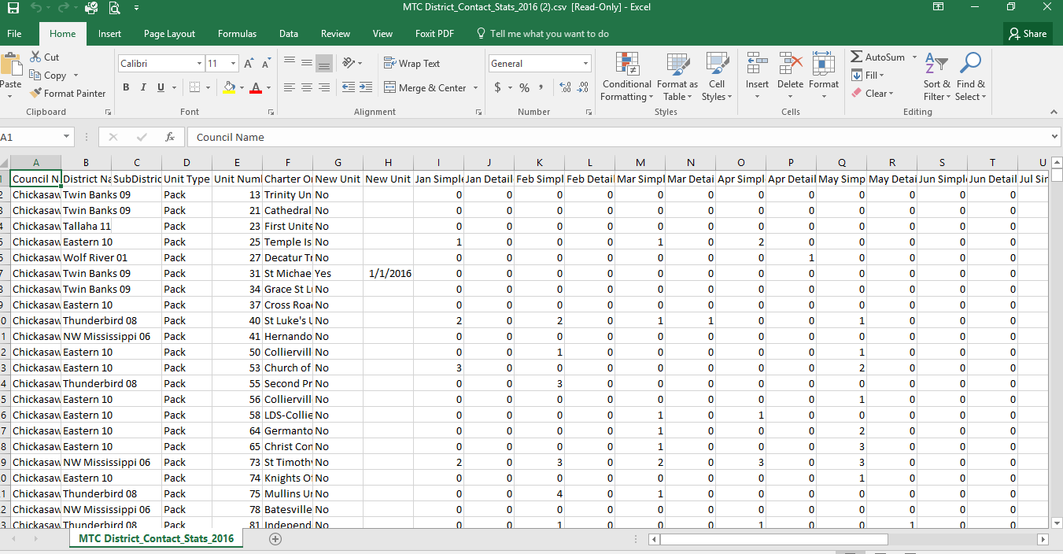
Step 3) Open the Power Pivot spreadsheet you previously downloaded and saved to your computer. In this case, the Commissioner Contact spreadsheet. When it opens it will automatically ask you to Import a Text file. Select the Commissioner Tools report that is needed for the spreadsheet, in this case the District Contact Stats 2016. Once selected the new spreadsheet will be generated.

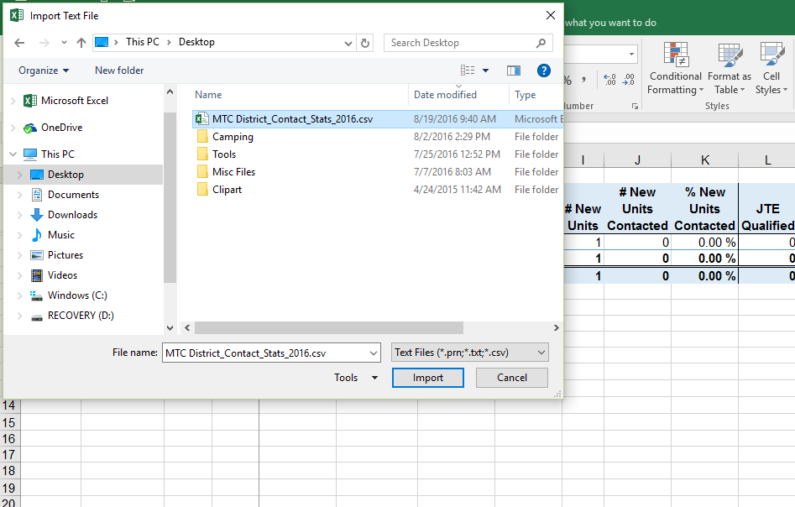
Step 4) Once the report generates you can save, print or analyze it the same as any other file. Note the multiple tabs with additional reports contained within each spreadsheet at the bottom of the screen.
