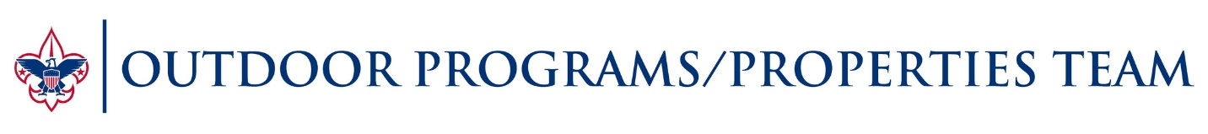
Boy Scouts of America Pistol Program for 2018
The following chart has been created from the Boy Scouts of America Shooting Sports Manual. Please refer to pages in the manual when using the chart below for qualified supervision, ratios of students to instructors, etc.
 | Level 1 | Level 2 | Level 3 | Level 4 | Level 5
SS Manual | Page 22 | Page 23 | Page 24 | Page 25 | Page 26
Boy Scouts | Not Allowed | Not allowed | BSA Safety and Marksmanship Program | Not Allowed | Not Allowed
Venturing | Recruitment of youth outside of BSA to join Venturing  Air Pistol Only | Free Shoot | BSA Safety and Marksmanship Program  or  NRA Pistol Blended Learning Program | Competition | NRA Apprentice, Assistant or  Instructor training

