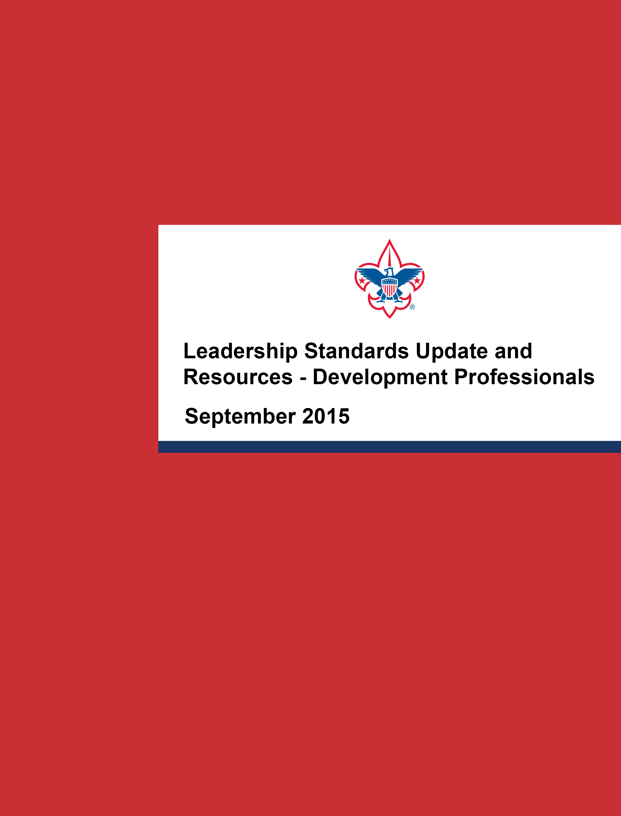

SUMMARY

On Monday, July 27th, 2015, the National Executive Board ratified a resolution that removes the national restriction on avowedly homosexual adult leaders and employees. The resolution was recommended for ratification by the Executive Committee earlier this month.
This change allows chartered organizations to select adult volunteer leaders without regard to sexual orientation, continuing Scouting’s longstanding policy of chartered organizations selecting their leaders. This policy also allows Scouting’s members and parents to select local units, chartered to organizations with similar beliefs, that best meet the needs of their families.
We have assembled resources about the policy change that may be helpful to you. If you have any questions about this matter, we encourage you to contact Ian Lilian in the Fund Development Team at 972-580-2116 and visit www.scoutingwire.org or www.scoutingnewsroom.org, where you will find video of Dr. Gates speaking to this matter.

WHAT YOU NEED TO KNOW

This page includes information and resources you may need to communicate with important stakeholders about adult leadership standards.

Five Key Facts

- The National Executive Board ratified a resolution that removes the national restriction on avowedly homosexual adult leaders and employees. The resolution is effective immediately.

- Chartered organizations will continue to select their adult leaders. Religious chartered organizations, solely, may continue to use religious beliefs as criteria for selecting adult leaders, including matters of sexuality.

- Scouting’s members and parents may continue to select local units, chartered to organizations with similar beliefs, that best meet the needs of their families.

- The youth membership policy adopted in 2013 is not affected by this resolution and remains unchanged.

- The ideals and principles of “duty to God” and “a Scout is reverent” set forth in the Scout Oath and Scout Law remain central to Scouting. Scouting is not an appropriate environment to discuss sexual conduct. While there is no national or local council restriction on avowedly homosexual adults serving as leaders or employees, everyone agrees to follow national policies and comply with the BSA’s behavioral standards.

What It Means
- For the BSA: Scouting is not an appropriate environment to discuss sexual conduct. While there is no national or local council restriction on avowedly homosexual adults serving as leaders or employees, everyone agrees to follow national policies and comply with the BSA’s behavioral standards.

- For Youth: Scouting is a youth program and no youth may be denied membership in the Boy Scouts of America on the basis of sexual orientation or preference.

- For Families: Parents can select units, chartered to organizations with similar beliefs, that best meet the needs of their families.

- For Adult Leaders: Unit leaders may apply for positions in units chartered to organizations with similar beliefs. At the district level and above, there is no restriction on avowedly homosexual adults serving as leaders.

- For Chartered Organizations: They will continue to select adult leaders, and religious chartered organizations may use religious beliefs as criteria for selecting adult leaders, including matters of sexuality.

By addressing this issue, the BSA is now able to continue to focus on its mission, preserve its core values, and provide life-changing experiences to youth they cannot get anywhere else.

KEY MESSAGES

The following key messages serve as the foundation for all communications—both written and spoken. For any questions about how to customize and use these messages with different audiences, please contact the BSA’s national communications team at PR@scouting.org.

Why We Made the Change:

- During the 2015 Boy Scouts of America National Annual Meeting in May, Dr. Gates encouraged the Scouting family to reflect on the challenges, primarily regarding adult leadership standards, facing the BSA and potential alternatives for addressing them. Dr. Gates’ remarks can be found on Scouting Newsroom.

• The BSA addressed the issue and set its own course to ensure it can continue to grow and provide life-changing experiences to youth they cannot get anywhere else.

Why This Resolution Is Right for Scouting:

- The BSA National Executive Board voted to ratify a resolution amending the adult leadership standards..

- Effective immediately, chartered organizations are able to select adult volunteer leaders without regard to sexual orientation, continuing Scouting’s longstanding policy of chartered organizations selecting their leaders. The 2013 youth membership policy is not affected and remains unchanged.

- This change allows Scouting’s members and parents to select local units, chartered to organizations with similar beliefs, that best meet the needs of their families. This change also respects the right of religious chartered organizations to choose adult volunteer leaders whose beliefs are consistent with their own.

- It remains the position of the BSA that the ideals and principles of “duty to God” and “a Scout is reverent” set forth in the Scout Oath and Scout Law are central to teaching young people to make better choices over their lifetimes.

Focusing on Scouting’s Mission:

- Scouting is not an appropriate environment to discuss sexual conduct, and the BSA will continue to have a strict behavioral standard for its youth members and adult leaders.

- Since 1910, the BSA has relied on chartered organizations to oversee and deliver the Scouting program in local communities. Nationally, Scouting represents approximately 2.4 million youth members and nearly 1 million adult leaders with diverse beliefs. Scouting teaches its youth members and adult leaders to be tolerant and respectful of different religious and moral beliefs, acknowledging that reasonable minds may honorably differ.

- Moving forward, Scouting will continue to focus on reaching and serving youth, helping them grow into good, strong citizens. By focusing on the goals that unite us, we are able to accomplish incredible things for young people and the communities we serve.

FREQUENTLY ASKED QUESTIONS

The following represent the most frequently asked questions you are likely to receive, as well as recommended responses. These, in their current form, are intended for internal use only, but individual answers can be used with external audiences as needed.

- What is the policy change?
Effective immediately, chartered organizations will be able to select adult volunteer leaders without regard to sexual orientation, continuing Scouting’s longstanding policy of chartered organizations selecting their leaders. This change allows Scouting’s members and parents to select local units, chartered to organizations with similar beliefs, that best meet the needs of their families. This change also respects the right of religious chartered organizations to choose adult volunteer leaders whose beliefs are consistent with their own. The 2013 youth membership policy is not affected and remains unchanged.

- Who makes up the National Executive Board and Executive Committee?
The National Executive Board is the governing body of the National Council. The board is composed of elected members, regional presidents, and appointed youth members, and is led by the national president. There are 71 members of the National Executive Board and 17 Executive Committee members.

- What were the specific results of the vote?
Of those present and voting, 79 percent voted in favor of the resolution.

- Why did the BSA make this change now?
Due to the social, political, and legal changes taking place in our country and in our movement, the current adult leadership policy cannot be sustained. The best way to allow the BSA to continue to focus on its mission and preserve its core values is to address the issue and set its own course to ensure it continues to provide life-changing experiences to youth they cannot get anywhere else.

- How did you reach this decision? What was the process?
During the 2015 Boy Scouts of America National Annual Meeting in May, Dr. Gates encouraged the Scouting family to reflect on the challenges, primarily regarding adult leadership standards, facing the BSA and potential alternatives for addressing them. Based on these remarks, the BSA National Executive Board voted to ratify a resolution amending the adult leadership standards policy.

- Why does this change make sense for the organization?
. This change allows Scouting’s members and parents to select local units, chartered to organizations with similar beliefs, that best meet the needs of their families. This change also respects the right of religious chartered organizations to choose adult volunteer leaders whose beliefs are consistent with their own.

- Will my religious organization have to allow avowedly homosexual leaders?
Religious chartered organizations may continue to use religious beliefs as criteria for selecting adult leaders, including matters of sexuality.

- Will the Boy Scouts of America indemnify both religiously affiliated chartered organizations and civic-based chartered organizations?
The BSA will continue to legally defend—or indemnify—the rights of its religious chartered organizations to choose leaders whose beliefs are consistent with their own.

- What does it specifically mean to indemnify religious chartered organizations?
The adopted policy allows religious chartered organizations to use religious beliefs as criteria for selecting adult leaders. The BSA will defend and protect from loss religious chartered organizations that select their leaders based on good-faith religious beliefs.

- Will the BSA inform parents, youth members, or adult leaders if a leader in their unit is avowedly homosexual?
These issues should not be discussed in a Scouting context. Scouts will be directed to their religious leaders or parents to seek guidance on these matters. Leaders who violate the behavioral standards of the BSA by discussing these issues can be removed from Scouting.

- How does this change affect non-religious chartered organizations?
As they always have, chartered organizations will select their leaders and can require adult leaders to demonstrate behavior that exemplifies the highest level of good conduct and respect for others. Only religious chartered organizations may use religious beliefs as criteria for selecting adult leaders, including matters of sexuality.

- Is this the result of recent lawsuits or pressure from activists and sponsors? Is it the result of the recent decision by the U.S. Supreme Court on equal marriage and states’ rights?
Due to the social, political, and legal changes taking place in our country and in our movement, the current adult leadership policy cannot be sustained. The best way to allow the BSA to continue to focus on its mission and preserve its core values is to address the issue and set its own course to ensure it continues to provide life-changing experiences to youth they cannot get anywhere else.

- Can avowedly homosexual leaders who were previously removed rejoin the organization?
Adult leaders who were previously unable to serve in Scouting may apply for volunteer leadership positions and will be eligible for selection if otherwise qualified, regardless of sexual orientation or preference.

- Does this policy change apply to BSA employees?
BSA employees may not be discriminated against on the basis of sexual orientation, and we will continue to follow all local, state, and federal employment laws. For all staff positions that require BSA membership, we will consider all qualified and eligible persons for hire without regard to their sexual orientation.

- What will happen to local councils that have passed non-discrimination policies that do not align with this new national policy?
This resolution prohibits local councils from denying a charter to a unit that is following the beliefs of its religious chartered organization. The National Council will take action on a council that violates this provision.

- Will you consider changing the “duty to God” standard?
Duty to God and duty to country, as expressed in the Scout Oath and Scout Law, are the fundamental tenets of Scouting and always have been. It remains the position of the BSA that these ideals and principles are central to teaching young people to make better choices over their lifetimes.

- Can a avowedly homosexual adult be a Scoutmaster or unit leader?
Yes. If selected by the chartered organization, an otherwise qualified and eligible avowedly homosexual adult is eligible to serve as a unit leader.

TEMPLATE EMAILS TO KEY AUDIENCES

The resources below were created for councils that may receive a high volume of calls or questions following this update. In this case, these template materials can be used as needed, customizing the note for key audiences. For recommendations on customizing these resources, please contact the national communications team at PR@scouting.org.

To General Audiences:

SUBJECT: Adult Leadership Standards Update

Dear [insert intended audience member],

[Insert greeting, i.e., “Thank you for your interest in the Boy Scouts of America.”]

Along with the rest of the Scouting family, we have been reflecting on the challenges facing the Boy Scouts of America and potential ways to address them—primarily regarding adult leadership standards. Our primary focus has always been on serving America’s youth and providing the best program possible to our members. Our mission has not changed.

The BSA National Executive Board recently voted to ratify a resolution amending the adult leadership standards. Effective immediately, chartered organizations are able to select adult volunteer leaders without regard to sexual orientation, continuing Scouting’s longstanding policy of chartered organizations selecting their leaders. This change allows Scouting’s members and parents to select local units, chartered to organizations with similar beliefs, that best meet the needs of their families. This change also respects the right of religious chartered organizations to choose adult volunteer leaders whose beliefs are consistent with their own. It is important to note that the 2013 youth membership policy is not affected by this decision and remains unchanged.

Moving forward, Scouting will continue to focus on reaching and serving youth, helping them grow into good, strong citizens. By focusing on the goals that unite us, we are able to accomplish incredible things for young people and the communities we serve.

[Insert positive examples of upcoming council activities and programs, i.e., “We look forward to seeing you at our upcoming recruitment event, fundraiser, camping activity, etc.”]

If you have any questions or would like to discuss this policy change, please don’t hesitate to contact me at [insert preferred contact information]. You can also visit Scouting.org for more information on our policies. Thank you again for your support.

Yours in Scouting,

[Insert signature]

To Donors, Friends of Scouting:

SUBJECT: Adult Leadership Standards Implementation

Dear valued friend of Scouting,

Thank you for your continued support of our organization and the Scouting program. It is only with your support that we are able to continue delivering the nation’s foremost youth development program to our community. Along with the rest of the Scouting family, we have been reflecting on the challenges facing the BSA and potential ways to address them—primarily regarding adult leadership standards.

I am writing to provide you with an update on this matter. The BSA National Executive Board recently voted to ratify a resolution amending the adult leadership standards.

Effective immediately, chartered organizations will be able to select adult volunteer leaders without regard to sexual orientation, continuing Scouting’s longstanding policy of chartered organizations selecting their leaders. This change allows Scouting’s members and parents to select local units, chartered to organizations with similar beliefs, that best meet the needs of their families. This change also respects the right of religious chartered organizations to choose adult volunteer leaders whose beliefs are consistent with their own. It is important to note that the 2013 youth membership policy is not affected by this resolution and remains unchanged.

Moving forward, Scouting will continue to focus on reaching and serving youth, helping them grow into good, strong citizens. By focusing on the goals that unite us, we are able to accomplish incredible things for young people and the communities we serve.

[I look forward to meeting with you soon/seeing you at our upcoming event, etc.] Thank you again for your support.

Yours in Scouting,

[Insert Scout Executive signature]

###

