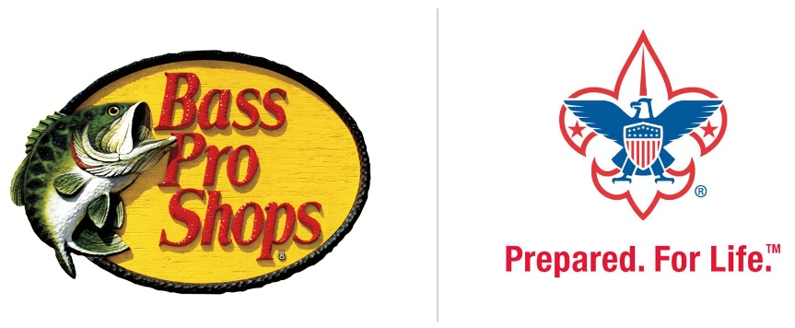
Frequently Asked Questions
Bass Pro Shops selection of the Boy Scouts of America as their primary promotional partner for its Boy Scout Month at Bass Pro Shops; “Providing a Compass for Life!” promotion has direct benefit to local councils and local units.

- What is Bass Pro Shops?
Bass Pro Shops (Outdoor World) is a privately held sports equipment and outdoor recreation goods store headquartered in Springfield, Missouri.

- What is Boy Scout Month at Bass Pro Shops; “Providing a Compass for Life!” Promotion?
In its seventh year, this multi-faceted event gives families the knowledge and ideas they need to maximize their enjoyment of the outdoors. The following are offered on Tuesdays, Thursdays, and weekends for the duration of the promotion (remember, everything is free!):

- Workshops for youth (suitable for ages 8–12) on subjects like fishing, Fish and Wildlife Management and rifle shooting. Following each workshop, participants complete a worksheet and earn a lapel pin. Opportunities are available to test youth bows, practice casting, shoot air rifles, and do other things.

- What dates does the promotion take place?
Boy Scout Month runs in all Bass Pro Shops stores for the entire month of September.

- Who may participate?
Anyone, including BSA employees, friends, family, volunteers, alumni and supporters are all welcome! They need only to visit their local Bass Pro Shops store.

- What if I don’t know where my closest Bass Pro Shops store is?
You can find your local Bass Pro Shop by utilizing their Store Locator. Simply type in your zip code and all of the information for the nearest store will become available to you.

- What’s in it for the Boy Scouts of America?
The BSA is being included in all Bass Pro Shops communication, advertising and promotion reaching tens of millions of people nationally. The BSA will see a tangible increase in awareness of Scouting, receive donations by customers from all stores, offer fulfillment of merit badge requirements through in-store workshops to Scouts, and allow young Scouts and their families to come out and participate in workshops preparing them for Boy Scouting.

- Can you tell me more about Scouts presence in stores?
Any time during September (but particularly on weekends, when traffic is highest), Scouts are encouraged to be store-front to talk to customers, sell Scouting fundraiser items such as popcorn (camp card sales are not allowed), solicit membership (youth and adults), and remind visitors of the donation program (explained below). Bass Pro Shops have offered covered, skirted tables and chairs for councils interested in providing coverage and will have in-store signage promoting Scouting.

- Can you tell me more about the donation program being offered in stores?
During the calendar month of September, Bass Pro Shops will offer customers an opportunity to donate their change, or round-up their total, to Boy Scouts. At the end of the promotion, 50% of the funds collected will be sent to the local council and the other 50% is designated to the National Council. Scouts presence store-front encouraging the donation with customers to increase results.

- Can you tell me more about the merit badge classes and workshops being conducted?
Bass Pro Shops is uniquely qualified to offer several workshops with merit badge requirements included. This year, Bass Pro Shops has chosen to highlight the Fishing and Rifle Shooting merit badges for Scouts. (Fishing does not include the final step of going fishing, and for the Rifle Shooting merit badge, they are using the air rifle option.)
Each store will select two or more associates to become certified as merit badge counselors, so we appreciate your council’s assistance in the certification process. A supply of “blue cards” will be available so counselors may sign off on completed requirements. Classes are taught on Tuesdays and Thursdays at 6 p.m. according to the following schedule:
Tuesday, Sept. 5 - Fishing  Wednesday, Sept. 6 - Rifle Shooting  Thursday, Sept. 7 - Fish and Wildlife Management | Tuesday, Sept. - 12 Fishing  Wednesday, Sept. 13- Fish and Wildlife Management  Thursday, Sept. 14 - Rifle Shooting
Tuesday, Sept. 19 - Fish and Wildlife Management  Wednesday, Sept. 20 -Fishing  Thursday, Sept. 21 – Rifle Shooting | Tuesday, Sept. 19 - Fishing  Wednesday, Sept. 20 – Rifle Shooting  Thursday, Sept. 21 – Fish and Wildlife Management

- Are class sized limited for the merit badge classes and workshops being conducted?
Yes, class size will be limited to ten (10) Scouts, so pre-registration will be necessary. Scouts may register at customer service or call the store and register over the phone.

- What if I want to spread the word about this promotion; are there marketing materials I can use?
Of course; the online toolkit has fliers, template letters, emails, and digital resources for anyone interested in spreading the word. If you are an employee of a local council, a parent, volunteer, board member, or just a supporter of Scouting, visit www.scouting.org/BassProShops .The toolkits include promotional fliers, template letters, template emails, digital resources, and social media updates.

- Can a local council create its own materials to distribute?
Only official promotional materials found on the online toolkit should be distributed. These materials are designed to be edited and personalized if needed. Any unauthorized use of BSA or Bass Pro Shops marks is prohibited and strictly enforced.

